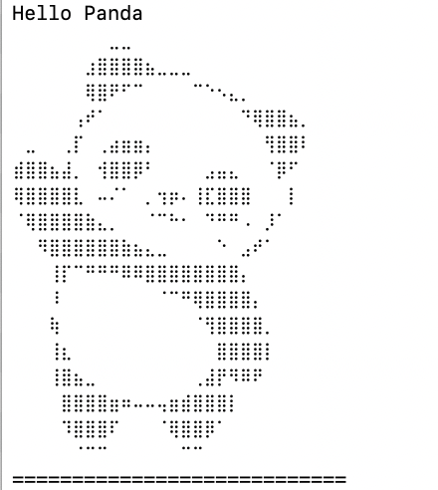
Student number: 210569373
Student Name: Kristin Schumann
Username in code: KSStripes

COMPUTER SCIENCE Object-Oriented Programming
December 2023

Terminal App for CryptoCurrency exchange - PandaRex
___________________________________________________________________________

Project Report
(Describe exactly how you carried out each task)

- Understanding the app and deciding which areas to modify for assignment.
Upon completion of all the videos and starter code, I first modified the name of the app to PandaRex, mainly to distinguish it from the former German chancellor. Then I identified the aspects of the app which I would have to build on top on to achieve the assignment.
It was quite clear that CSVReader.cpp and Wallet.cpp would not be changed much for the assignment. CSVReader reads in data from a CSV file and Wallet creates a wallet and a user to allow for transactions. As the assignment focusses mostly on market statistics, I would therefore mainly work in OrderBook, OrderbookEntry, Pandamain and my new classe(s).

- Refactoring: make PandaMain app leaner and console output more appealing
Before getting to work on the main assignment, I cleaned up the existing code with comments and tabs and refactored it to make the app more object-oriented and visually appealing for the user.
To CSVReader.cpp I added one line to close() the CSV file once read in, as I was going to deal with a much larger dataset. I also transformed the processUserOptions() into a switch statement to make it shorter.
To display the wallet, I used a for-loop to display a wallet-like container and show the money within it. Moreover I placed the printWallet() function within Wallet.cpp to make PandaMain app more focussed on just the app(menu). I also created some “attractive” ASCI-art for the opening page and the wallet.
Finally, I created a UserInput class to deal with asks and bids in a specific constructor.
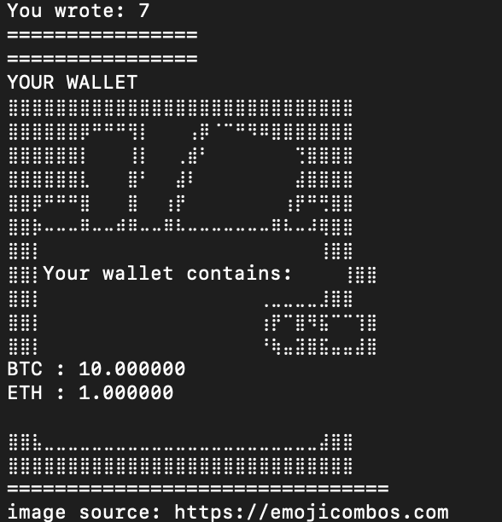
Figure 1Wallet image

- Accomplish Task 1: Candlesticks Vector with Open, High, Low, Close Statistics
I first initiated a new CandleStick class and outlined in the comments in pseudocode what this class should do:
/** function generateCandlesticks
* takes orderBook as a reference
* initializes a vector of vectors std::vector<Candlestick> candlesticks returns a vector of candlestick objects
* declares double variables for open, high, low and close as arguments of each candlestick object
* computes these four variables by calling the corresponding OrderBook functions
* : open = orderBook.getMeanOpen(OrderBookType::ask, p, prevT)
* : high = OrderBook::getHighPrice(entries)
* : low = OrderBook::getMinPrice(entries)
* : close = OrderBook::getMeanPrice(entries)
* Loops over all orderBookEntry& orders
* for each timestep retrieves open, high, low, close and passes them into an object candlestick
* pushes this object back into the vector of vectors <Candlestick>
* returns a vector of candlestick objects
*/
OrderBook class already had functions for getMinPrice(), getHighPrice(), getEarliestTime() and getNextTime(). To advance with the full calculations for the Candlesticks vector, I added some statistical analysis in the OrderBook, including functions for getPreviousTime, getMeanPrice() and getMeanOpen(). If the entry had no previous time, I adjusted the code so that the function would work with the last entry of the CSV. To progressively ensure that these functions were outputting the correct statistics, I adapted option menu 2. Print Market Statistics to print out Control Values in a table format.
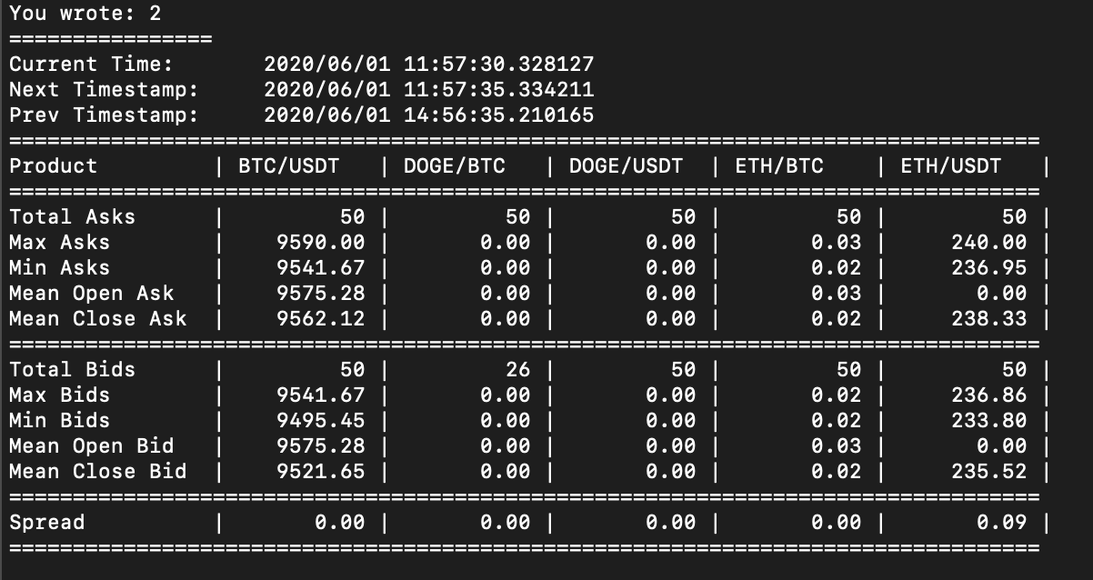
Figure 2 Menu 2 output control input calculations for Candlesticks
I created two candlestick generation functions.
First, std::vector<Candlestick>getAllCandlesticks(), obtains all Candlestick data from the Orderbook and generates the data for 5 different objects.
Secondly I developed the more fancy std::vector<Candlestick>getOneCandlestick() which takes the UserInput on product type and order type. To achieve this, in my UserInput class I typed a menu for the user of all the possible order types and product types. Then I used the tokenize function that we we were given with the started code and passed this input into getOneCandlestick. To achieve this, I also had to create a small function to map the user input for the order type from string to the enum class options.
The resulting print to the terminal used the user input to precisely type the data for one candlestick at one time moment.
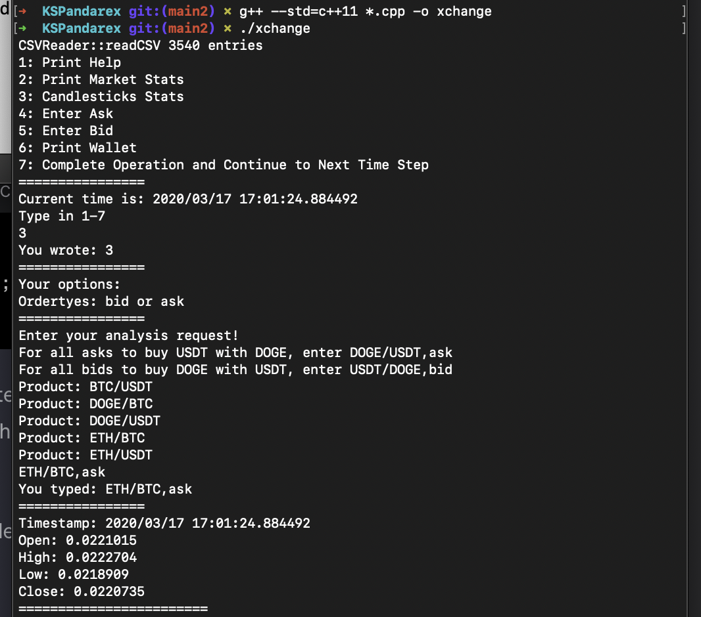
Figure 3 Terminal output of data for one candlestick according to user request

However, in the end I chose not to implement the user requested candlestick data because it was cumbersome (lots of typing) for just one candle which was often of all the same values. The userinput function would have been nice if I had managed to print several candlesticks next to each other or been able to get my time buckets to work, but as it was, the displayed graph was too cumbersome and meaningless.

- Accomplish Task 2: Create a Text-Based Plot of the Candlestick Data
I created the printCandlestickChart() function in the Candlestick class, with the aim to create a graphical representation of the candlestick data.
I set out in bullet points what the function had to take as parameters and to output:
- It takes as input four numerical values (open, high, low, and close) for each object passed in from the getOneCandlestick class. This represents the price range for one product and order type during a specific time interval, along with its timestamp.
- The function first needs to check if any of the input values are zero or smaller, as this would render the graph meaningless, and in such cases, it displays an error message and skips the graph generation.
- The function then calculates the range of values to be displayed on the vertical (y) axis of the graph. This is necessary because the values are quite different, and I needed the candlestick y-axis to start its lowest point a little lower than low and to end a little higher than high. I ensured this by calculating margin of three steps both at the top and bottom of the graph.
In the following figures you see how data returned for ETH/BTC,bid returns values in the 0.022 range, whereas for ETH/USDT,ask the values are 117 to 121. The y-axis values need to adjust to each product type by calculating stepSizes based on these values. One graph for all products is meaningless.

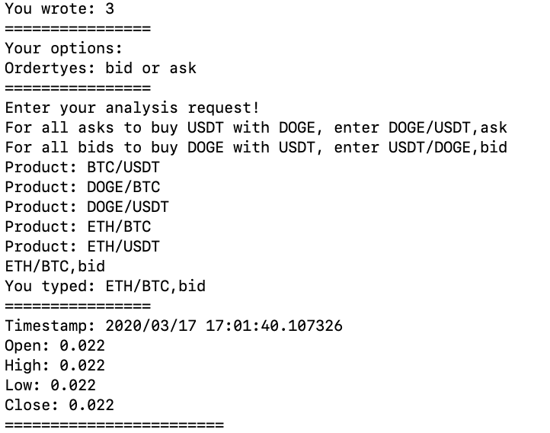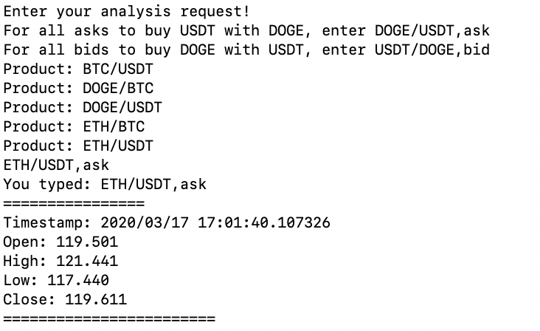

I constructed the graph itself of text-based characters:
- One candlestick would represent the price movement during the time interval
- The height and appearance of these bars depend on the input values.
- '□□□□□' for the candlestick body with a sinking market (open > close)
- '■■■■■' for the candlestick body with a rising market (close > open)
- ' | ' for the candlestick wick
- For other cases, it prints spaces, so that there would be no graph drawn.
- The x-axis labels at the bottom of the graph show the timestamp of the data.
To achieve the printing of the timestamp in the x-axis as 17:01:40 rather than the full timestamp of the CSV (2020/03/17 17:01:40.107326), I created a helper function extractTime() in CandleStick.cpp that would define a regular expression pattern to match the part of the data that I was interested in: std::regex pattern("\\d{2}:\\d{2}:\\d{2}").
I then called the printCandlestickChart() from UserInput on the requested product and order type. I realized that I needed to shorten the output of getOneCandlestick() to 3 decimal places after the comma. Otherwise, it broke my code.
Once one candlestick had been created for all products, I needed to find a way to print several of them next to each other. Unfortunately I tried all sorts of for-loops and range loops and couldn’t get my code to work.
Next I tried to implement time the time buckets inside the orderbook. I decided that the 1Mio+ entries, which covered 3 hours, would fit nicely into 36 timesteps of 5 minutes. But whatever I tried, I produced 36 time buckets with one time stamp (476 entries) per bucket and all the others at the end.
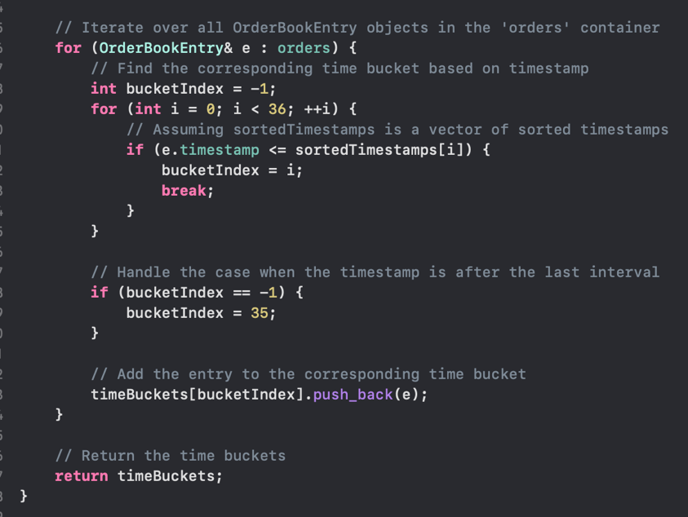
Figure 4Broken OrderBook::getTimeBuckets()
I faced another problem with data scaling. Although I had calculated my candlestick graph to be calculate it’s stepSize based on the low and the high values, some of the close and open values were so close to one another that it didn’t show at all in the graph. The following image shows this for dummy data vs a real time set. Moreover, I also was unable to loop through all timestamps and print several candlesticks for one product next to each other.
Here are a few images to show you that I did manage to come up with attractive text graphics, but unfortunately the way I called the data, reduced their overall interest:
- Graph only ever covers the current timestamp (around 480 entries)
- I could not get them to print next to each other
- Due to reduced time frame, the scaling is obviously off, as there is little variation sometimes the data will show, sometimes it is too small
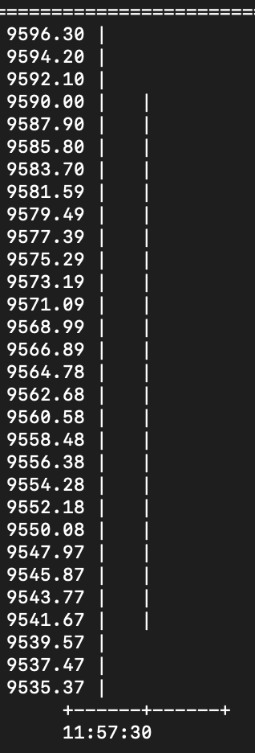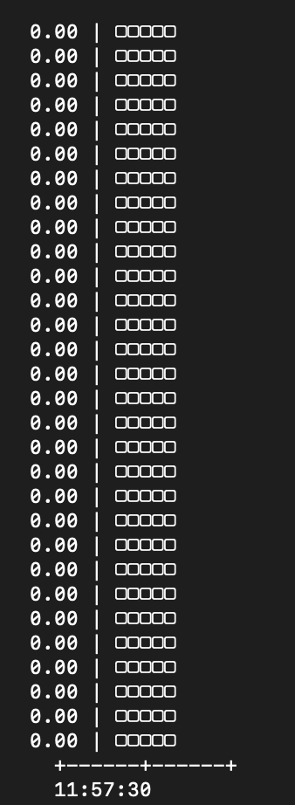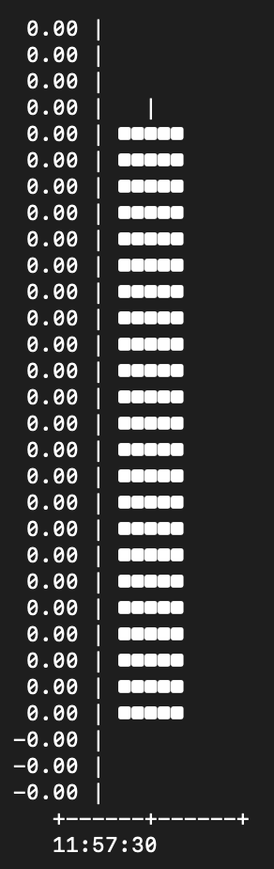

- Accomplish Task 3: Create a different Text-Based Plot Based on the Given Data

For the final task, I chose to implement a bar chart of spread data. In financial markets, the "spread" typically refers to the difference between the lowest ask price (the price at which sellers are willing to sell a financial instrument) and the highest bid price (the price at which buyers are willing to buy the same financial instrument) for a particular product at a specific point in time. It is frequently used by traders to assess where in the current market they have the biggest risk and the biggest opportunities.
I first created a function to return a double for the spread of one product at one time. This function takes two parameters: the product obtained from the orderbook and the current timestamp. It then uses the already existing getMinPrice() and get HighPrice() functions to calculate the lowest ask and the highest bid at that time. It returns the double of one spread for one product at that time.
I then created a SpreadPlot class, where I created a std::vector<std::pair<std::string, double>> spreadPairs to push all spreads for all products at that time stamp.
Next, I needed to think of a way to show this vector as a bar chart graph.
My idea was simple: take the vector of doubles and print a line of “■■■■■” for the bars scaled to the size of the double that was the spread for that product.
My final implementation reveals a major problem, like my scaling problem for the candlestick: the differences in values are sometimes very small. This is logical: as I was not able to implement my time buckets, I could not cluster data for 5 minutes which would have increased the spread: Therefore my bar chart shows a lot of empty data.
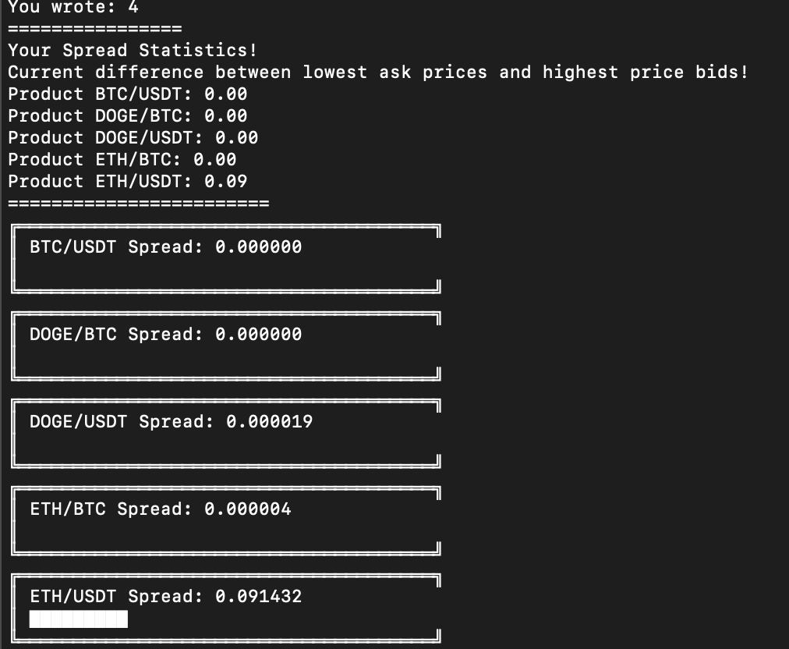
Figure 5Bar graphic showing the spread value for each time stamp and product

Originality
(Describe which aspects of your work were challenging/original/creative/exceptional)
- I started with the user friendliness. I wanted to have any user understand clearly what to do upon each menu option and I wanted things to be visual, not just the graph. So, I implemented more explanations for the individual menu steps a visual entry page showing a Panda (for PandaRex) and a wallet graphic.
- For the rest of the originality, I am pretty sure that there are better and more functional implementations. This was my first go at OOP and at C++ and I’m quite happy I made it this far.

References
- Website for the ASCII art : https://emojicombos.com/panda-ascii-art

